**Project: Customer Retention**

**Problem Statement:** Customer satisfaction has emerged as one of the most important factors that guarantee the success of online store; it has been posited as a key stimulant of purchase, repurchase intentions and customer loyalty. A comprehensive review of the literature, theories and models have been carried out to propose the models for customer activation and customer retention. Five major factors that contributed to the success of an e-commerce store have been identified as: service quality, system quality, information quality, trust and net benefit. The research furthermore investigated the factors that influence the online customers repeat purchase intention. The combination of both utilitarian value and hedonistic values are needed to affect the repeat purchase intention (loyalty) positively. The data is collected from the Indian online shoppers. Results indicate the e-retail success factors, which are very much critical for customer satisfaction.

**Analysis**

1. The Shape of the data set is 260 rows and 71 Columns
2. There are more number of Female when Compared to Male in this Dataset

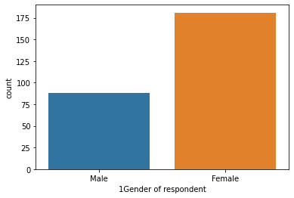

1. Below is the Graph which shows the age of people This graph give the clear idea that most of the people has the age in the range 31 to 40

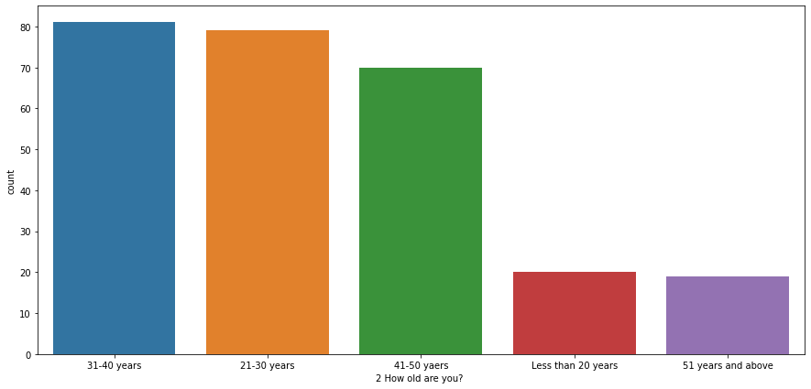

1. The below graph shows that most of the people who gave their opinions are from Delhi

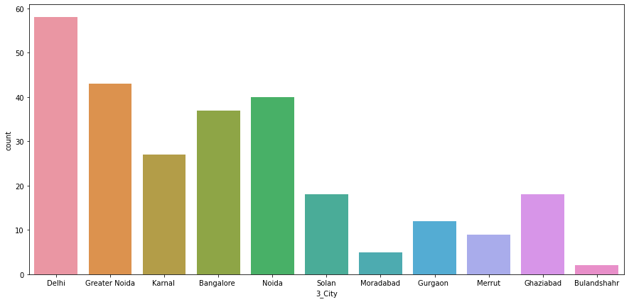

1. The below Graph shows that most of the people uses Mobile internet of online Shopping and they are mostly from Greater Noida

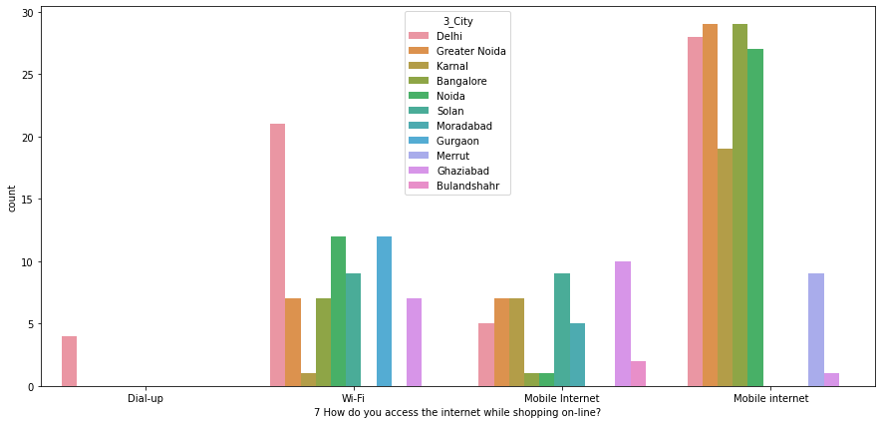

1. Most of use Smartphone to access the online shopping are mostly from Bangalore

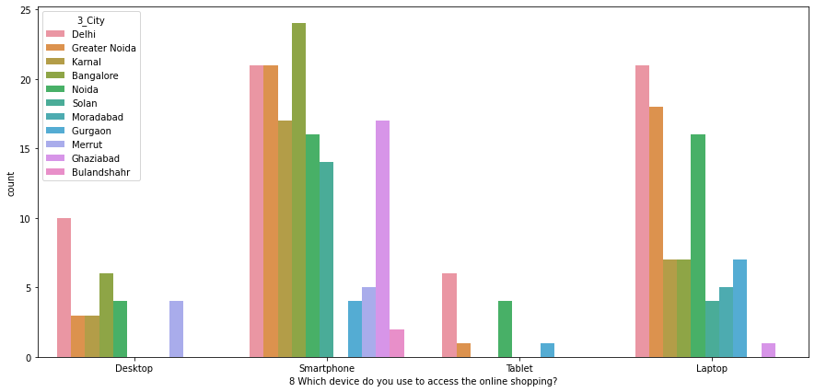

1. The below graph show that Majority of people use Google Chrome to acess the online shopping services

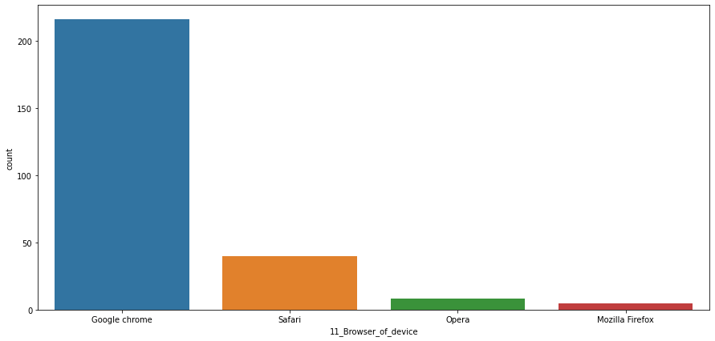

1. The below graph shows that most of the people uses Credit/Debit Cards as their payment option

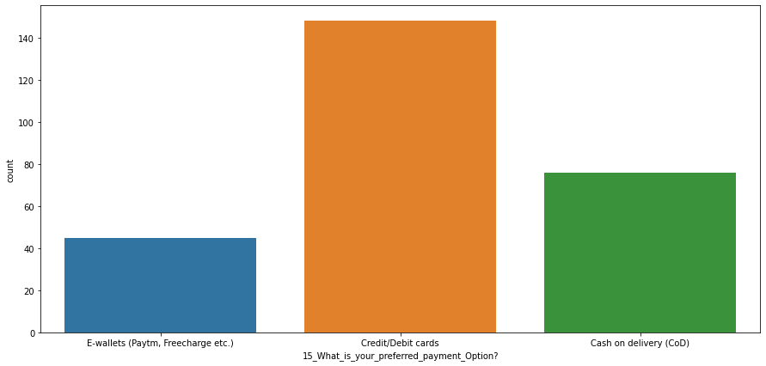

1. The below graph shows that most of the people abandon_the_“Bag”,_“Shopping_Cart” because they got better deal

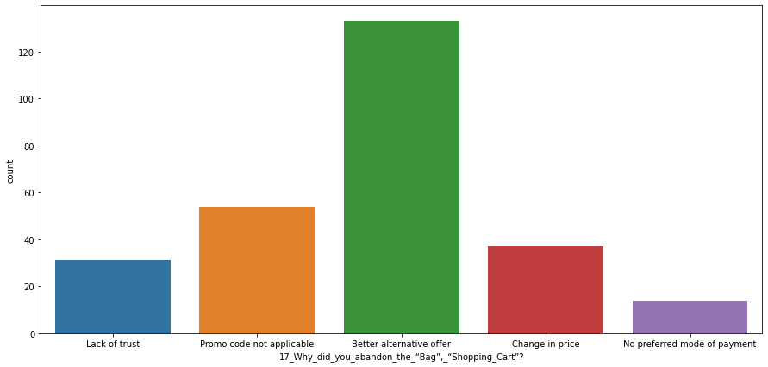

1. Analysis shows that most of the people agree that the website must be easy to read and understand
2. Analysis shows that Most of the from delhi agree that Information on similar product to the one highlighted is important for product comparison
3. Analysis shows that Most of the people agree that Complete information on listed seller and product being offered is important for purchase decision.
4. Analysis shows that Most of the people agree that All relevant information on listed products must be stated clearly
5. Analysis shows that Most of the people Strongly agree that A Good E-commerce website should have Ease of navigation .
6. Analysis shows that Most of the people Strongly agree that A Good website should have Good Loading and processing speed
7. Analysis shows that Most of the people Strongly that there should be User friendly Interface of the website.
8. Analysis shows that most of the people Strongly agree A good E-commerce website is that Being able to guarantee the privacy of the customer
9. Analysis shows that most of the people Strongly agree that Return and replacement policy of the e-tailer is important for purchase decision.
10. Analysis shows that most of the people Strongly agree that Displaying quality Information on the website improves satisfaction of customers
11. Analysis shows that most of the people Strongly agree that Gaining access to loyalty programs is a benefit of shopping online
12. Most of the people Strongly agree that Monetary savings is the good thing.

**Conclusion:**

**A Good website E-Commerce website should have the following qualities for customer retension**

1. Easy to use website or application',
2. 'Visual appealing web-page layout',
3. 'Wild variety of product on offer',
4. 'Complete, relevant description information of products'
5. 'Fast loading website speed of website and application'
6. Reliability of the website or application',
7. Quickness to complete purchase',
8. Availability of several payment options',
9. 'Speedy order delivery ',
10. Privacy of customers’ information',
11. Security of customer financial information',
12. 'Perceived Trustworthiness',
13. Presence of online assistance through multi-channel',

**A Good website E-Commerce website should not have the following:-**

1. Longer time to get logged in (promotion, sales period)',
2. Longer time in displaying graphics and photos (promotion, sales period)',
3. Late declaration of price (promotion, sales period)',
4. Longer page loading time (promotion, sales period)',
5. Limited mode of payment on most products (promotion, sales period)',
6. Longer delivery period', '
7. Change in website/Application design',